* To install on cmd , write **npm install –-save express** .
* Npm install -g packageName is used to install package globally,
* Creating a server with express: we have to define our port number





* After creating server, we can add as many middleware as we want, but we have to call the next () otherwise the request will not go to the next middleware. 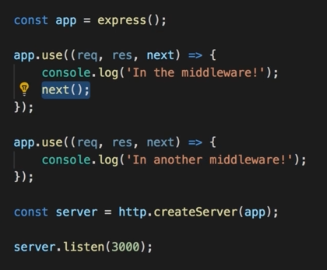
* We can define path(or bunch of paths) too as an argument for the use() method
* We can limit the middleware execution to either post or get only. In such cases instead of using app.use() , we replace it by using app.get() or app.post(). Rest of the synstax will be same
* We typically will use routers to navigate. For this we need to define a router const. 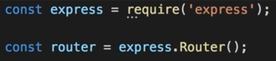

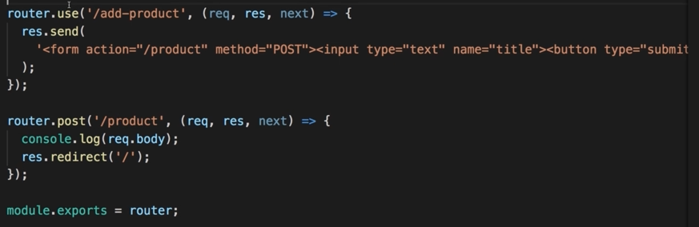

* In cases of paths, things to remember:
  + **/view**  this means absolute path of the operating system,
  + **./view**  this means the root path of the app.
  + Different OS have different path implementation. So we use a helper function to define path.
  + **..**  means up one level from current folder.
* **__dirname** holds the absolute path of the operating system to the project folder, and the next segments are the path. We don’t use / here.

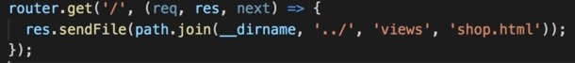

* Users doesn’t get access to the files in the server, so when we link the css or js files in the html pages and send them to users, they won’t get the style or scripts, since the files itself which are linked inside are not accessible. The solution is keeping a folder that is accessable. We can name it Public and let it read only access